1. Create project like the following figure:

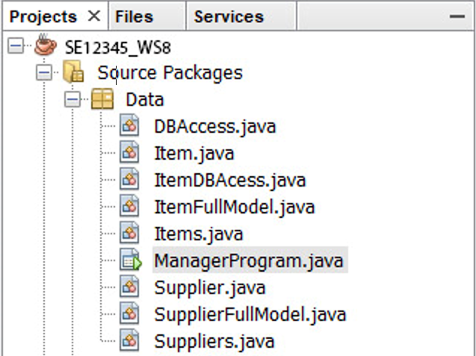

1. Develop the program for managing items using MS Sql Server JDBC**(10 marks)**

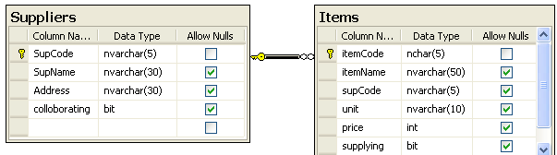

* Database:



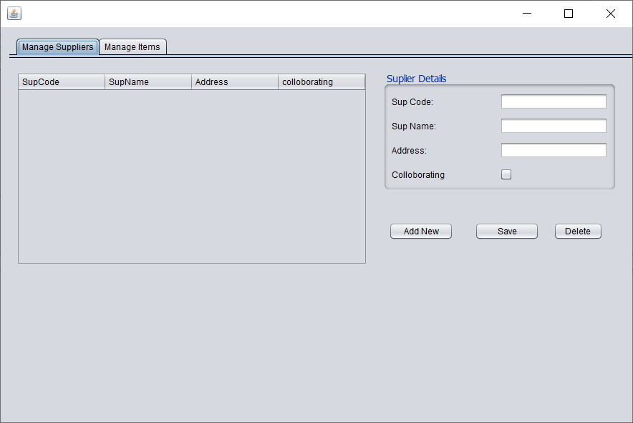

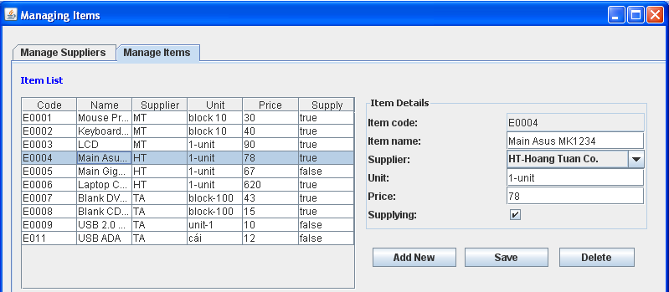

Performance requirements:

Write code that performs the functions as shown above.